An IN parameter passes a value into a procedure. The procedure might modify the value, but the modification is not visible to the caller when the procedure returns.

An OUT parameter passes a value from the procedure back to the caller. Its initial value is NULL within the procedure, and its value is visible to the caller when the procedure returns.

An INOUT parameter is initialized by the caller, can be modified by the procedure, and any change made by the procedure is visible to the caller when the procedure returns.

DELIMITER $$

DROP PROCEDURE IF EXISTS sp_nested_loop$$

CREATE PROCEDURE sp_nested_loop(IN i INT, IN j INT, OUT x INT, OUT y INT, INOUT z INT)

BEGIN

DECLARE a INTEGER DEFAULT 0;

DECLARE b INTEGER DEFAULT 0;

DECLARE c INTEGER DEFAULT 0;

WHILE a < i DO

WHILE b < j DO

SET c = c + 1;

SET b = b + 1;

END WHILE;

SET a = a + 1;

SET b = 0;

END WHILE;

SET x = a, y = c;

SET z = x + y + z;

END $$

DELIMITER ;

**Network Protocol driver**

The Network Protocol driver uses middleware (application server) that converts JDBC calls directly or indirectly into the vendor-specific database protocol. It is fully written in java.

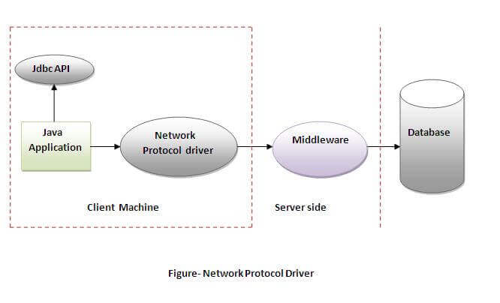

**Advantage:**

No client side library is required because of application server that can perform many tasks like auditing, load balancing, logging etc.

**Disadvantages:**

Network support is required on client machine.

Requires database-specific coding to be done in the middle tier.

Maintenance of Network Protocol driver becomes costly because it requires database-specific coding to be done in the middle tier.

1. IBM
2. Oracle
3. MySQL
4. Microsoft SQLServer
5. PostgreSQL